CA-21
2016 IE Strategy Memorandum

Updated on 5/2/16
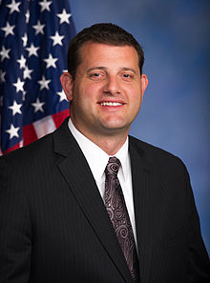
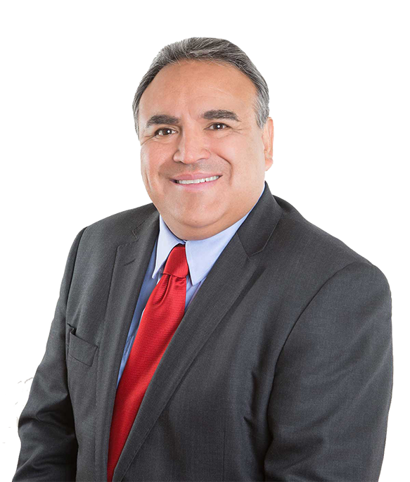

EMILIO HUERTA CONGRESSMAN DAVID VALADAO
CoH: $116,158.74 CoH: $1,139,306.12
Date: 4/15/16 Date: 4/15/16
Occupation: Civil Rights Attorney Occupation: Congressman/ Farmer/ Small Businessman
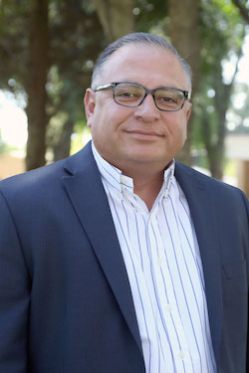

DANIEL PARRA
CoH: $11,186,.57
Date: 4/15/16
Occupation: Councilmember/ Defense Analyst

SECTION I: Race Overview
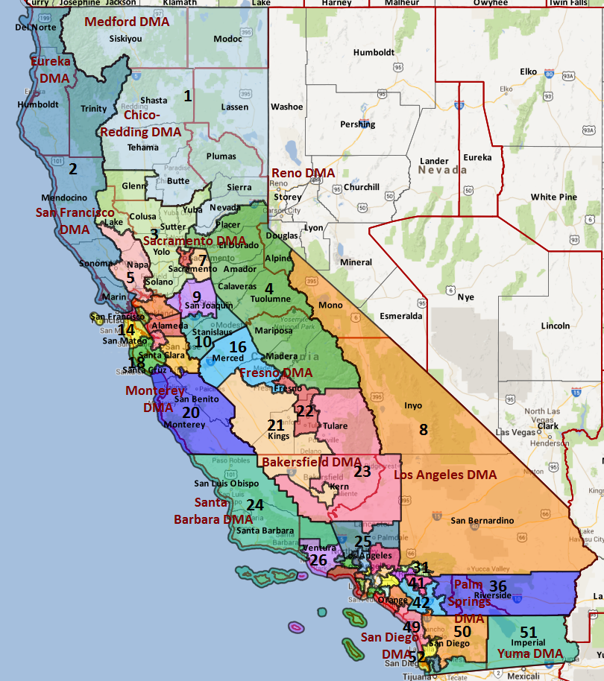

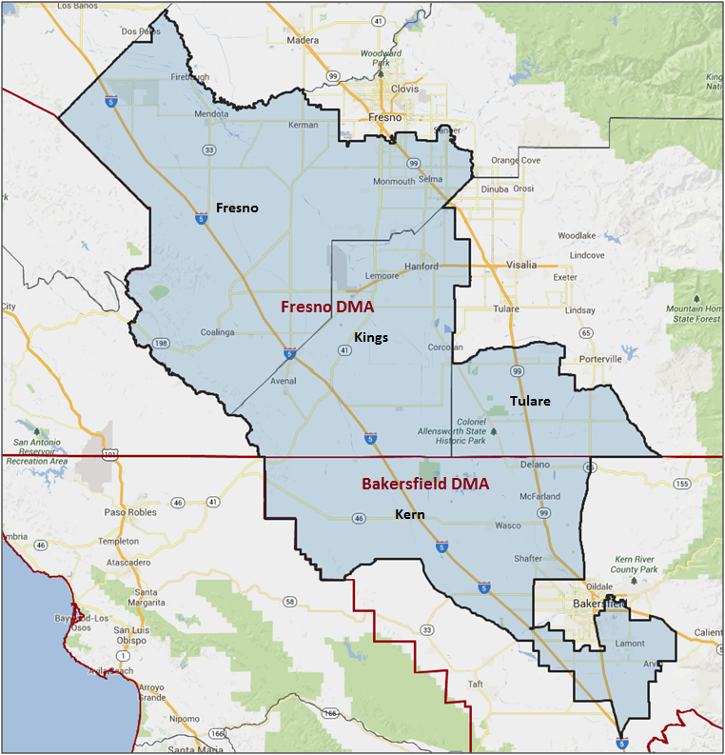

Media Market Costs

TV DMA | % of  CD | I.E.  35+ CPP | Cable CPP
FRESNO-VISALIA | 64.5% | $120 | $66
BAKERSFIELD | 35.5% | $87 | $112
CA-16 TOTALS: | 100.0%
Radio Landscape

Fresno
Universe Size | CPP
447,500 | $60

Bakersfield
Universe Size | CPP
356,00 | $125

Visalia
Universe Size | CPP
271,800 | $55

Digital Landscape
  - Persuasion universe size: 13,190
  - Audience extension (key demos): Hispanic, 18-30
  - Weekly budget for full coverage: $4,785.35
  - Reach
    - YouTube - 301,811
    - Pandora - 320,296

Presidential Statistics
Cycle | Candidate | Party | Vote
2012 | Obama | DEM | 52.5%
2012 | Romney | REP | 47.5%
2008 | Obama | DEM | 55.7%
2008 | McCain | REP | 44.3%

Congressional Statistics
Cycle | W/L | Candidate | Party | Vote
2014 | L | RENTERIA | DEM | 42.17%
2014 | W | VALADAO | REP | 57.8%
2012 | L | HERNANDEZ | DEM | 42.2%
2012 | W | VALADAO | REP | 57.8%

NCEC Data
Dem Performance: 52.8%
BVAP: 7.3%
Hispanic: 53%
Asian: 4.4%
Total Minority: 64.7%

Critical Dates
Filing Date: March 25th 2016
Primary Date: June 7th 2016

Summary of 2014 Cycle Spending by Outside Groups to Date

TV Competitive Summary – Bakersfield
Campaign/Group | Total GRPs | Total Dollars
Renteria/DCCC | 293 | $29,280
Chamber of Commerce | 2,181 | $187,776
Good Guys vs Bad Guys | Total GRPs | Total Dollars
Good Guys | 293 | $29,280
Bad Guys | 2,181 | $187,776
TV Competitive Summary – Fresno
Campaign/Group | Total GRPs | Total Dollars
Renteria/DCCC | 543 | $65,120
Valadao/NRCC | 368 | $44,175
Chamber of Commerce | 2,689 | $338,073
Good Guys vs Bad Guys | Total GRPs | Total Dollars
Good Guys | 543 | $65,120
Bad Guys | 3,057 | $382,248

Pre-Election Day Voting

Type of  “Early Voting” | Start Date  End Date | Percent of  Vote Cast Using this Method | Brief Description  (where/how  do people vote) | Timeframe (when does the majority of voting happen)
Early Vote | Oct 8 –Nov 8 |  | Voters can bring their early ballots to the board of elections office or be issued a ballot at the office at the time of their visit | Steadily between Oct 8 – Nov 7
Absentee Ballot/In person Absentee | Oct 10 – Nov 11 |  | Voters must apply for an absentee/VBM ballot via mail, online, or in person | Absentee applications must be received by BOE at least 7 days before election day
Vote By Mail | Oct 1 – Nov 11 |  | Voters must request to VBM each election unless on PEVL - VBM must be received by BOE by Nov 11 and be postmarked before election day | Ballots return steadily.

Tentative Campaign Timeline

IMPORTANT DATES

VBM: Oct. 10 – Nov. 1

- Counties will begin sending out PAV ballots on October 10, 2016. Voters may submit a mail application to vote by mail by November 1, 2016 and can apply to vote by mail in-person thereafter. In 2014, Kern and Tulare Counties offered early voting on the weekend before Election Day at their respective county elections offices. No announcements have been
made for 2016.
- In 2014, nearly half (47.7%) of the electorate voted by mail and almost 68% of ballots were returned in the final two weeks of the election. The percentage of mail ballots cast was even higher in the Presidential year as 60% of 2012 ballots were cast via mail.
- Democrats had a 7-point advantage for vote-by-mail ballots returned in 2012 (46% to 39% with 15% DTS) and an 11.5 point advantage in 2014.
- According to modeled support and the Secretary of State’s records, Renteria won just 40.2% of Election Day ballots in 2014, but 44.3% of vote-by-mail votes. If this trend continues in 2016, a Democratic candidate would have to win 36,298 votes or 64.8% of mail ballots to achieve our 52% vote goal.

SECTION II: DISTRICT OVERVIEW

- District Overview and Data

  - Political Landscape
- Two-term Republican Congressman David Valadao is running for re-election in 2016. The popular Republican Congressman has benefited from a weak Democratic bench in 2012 and historically low midterm turnout in 2014.
- Two Democratic candidates are running to replace Valadao: Fowler Mayor pro-tem Daniel Parra and Bakersfield attorney Emilio Huerta. So far, Perra has to been unable to fundraise, but claims ties to local activists. Huerta, a successful labor attorney, is the son civil rights icon Dolores Huerta. According to Amanda Renteria’s August 2014 benchmark of likely 2014 general election voters, Dolores Huerta is a polarizing figure in the district. Huerta had an 8% favorable/ 23% unfavorable rating among White voters but a 59% favorable/ 11% unfavorable rating among Latino voters. Latino voters over 65 years old had the most positive view of Huerta, at 69% favorable and only 10% unfavorable. Voters who spoke only Spanish or mostly Spanish at home were the most familiar with Huerta, and had +70 and +73 favorable views of her, respectively.

  - District Demographics
- CA-21 is a large district in California’s rural Central Valley and includes the Bakersfield suburbs, Fresno suburbs, and the city of Hanford.
- The Fresno media market covers 60% of the district and costs an average of $111 per political point. Bakersfield covers the other 40% of the district and costs $67 per political point. Communicating in both Spanish language and English language broadcast and cable has proven critical to an effective paid communications program, given that an estimated 36.2% of the population speaks Spanish.
- According to the latest Secretary of State’s data, CA-21 has a 16 percentage point Democratic registration advantage, but only a 52.8% Democratic Performance Index. As a whole, the district is heavily Latino, less educated, younger and less prosperous than the rest of the state. White, rural Kings County, which produced 28% of the 2014 vote, is the only area of the district with a Republican registration advantage.
- Voters in California register with a party or “decline to state.” All references to party in this document refer to actual party registration unless otherwise noted.

District Demographics

- Cook Partisan Voting Index: Lean Rep
- Urban Population: 24%
- Rural Population: 32.6%
- Suburban Population: 43.4%
- Median Income: $36,972
- Poverty Status: 7.2%
- Military Veterans: 23.2%
- Race/Ethnic Origin: 35.3% White; 7.3% Black; 4.4% Asian; 53% Hispanic Origin

  - Electoral Context
- The outcome of the Senate primary race will affect the top-of-ticket coattails in this district. Senate candidates, especially Kamala Harris, will likely play in Bakersfield and Kern County, but will not touch the rural areas that are key to a Democratic congressional campaign. Loretta Sanchez has already shown an interest in consolidating support in the district, criticizing Harris for failing to visit the Central Valley.
- The competing SEIU minimum wage ballot measures may employ field staff in the Central Valley to supplement the field work they do in other parts of the state.
- The new Senate Bill 29 will affect voting in the 2016 cycle. Absentee ballots will now be accepted if they are postmarked on or before Election Day and are received no more than 3 days after Election Day. Previously, only ballots that were received by Election Day were counted. The new DMV Motor Voter law will not be in effect for the 2016 cycle.

  - Press Presence
- The Fresno media market covers 60% of the district and costs an average of $111 per political point. Bakersfield covers the other 40% of the district and costs $67 per political point. Communicating in both Spanish language and English language broadcast and cable has proven critical to an effective paid communications program, given that an estimated 36.2% of the population speaks Spanish.
The English press corps has closely followed this district and has bought into the local/national fight, making DCCC positive earned media challenging.

Spanish media is particularly excited about Huerta’s run, but is historically favorable to Valadao.

Bakersfield
- Bakersfield Californian - Paper of Record, James Burger
- KBAK (CBS)
- KERO (ABC)
- KGET (NBC/Telemundo)
- KABE (Univision)

Fresno
- The Fresno Bee - Paper of Record, John Ellis
- KSEE (NBC)
- KFSN (ABC)

SECTION III: MESSAGE

Message Box

Democrat Self Frame  Washington is leaving the Central Valley behind and it’s time for real measurable change. I was born and raised in the Valley by the leaders of the historic farmworkers’ movement and witnessed firsthand what working men and women can accomplish together. I’m running for Congress to empower the Valley and stop Washington from holding our families back.  We’ve all seen Central Valley families struggle year after year, and it’s never been more difficult to get ahead. Good paying jobs are hard to find, Congress keeps playing politics with our water, our underfunded schools are failing our children, and Washington threatens to take away our seniors’ hard-earned benefits. | Republican Self Frame  Valadao is fighting for the Valley’s number one issue: water.  Valadao is an independent voice who continues to fight for immigration reform.
Likeliest Attacks on Democrat  Does not live in the 21st district.  Receives contributions from environmental supporters opposed to drought relief for the Central Valley.  Vulnerabilities connected to United Farm Workers. | Best Attacks on Republican  Valadao is now part of Trump’s Republican Party. Trump’s immigration policies are particularly damaging for Valley families  Valadao would end Medicare and privatize Social Security - he is even more extreme than Donald Trump.

- Emilio Huerta (D)

- Short Biography
Emilio J. Huerta is a lifelong resident of Kern County in the central San Joaquin Valley of California, and lives in Bakersfield, California. He possesses a Bachelor of Arts degree in political science from California State University Bakersfield and a Juris Doctorate degree from Santa Clara University School of Law. As the son of Dolores Huerta who witnessed firsthand the organizing leadership of Cesar E. Chavez and Dolores
As a public-interest attorney, Emilio has dedicated his career of more than 20 years to improving the lives of working men and women. He has served on numerous nonprofit boards, including Greater Bakersfield Legal Assistance (board chair), Self Help Federal Credit Union (board chair), The Bakersfield Aids Project, Kern Central Credit Union, the Betty Ann Ong Foundation, the Cesar Chavez Service Clubs, and the California State University Hispanic Excellence Scholarship Fund.
Prior to attending California State University Bakersfield, Emilio served as a labor negotiator, representing farmworkers throughout California.

- Self-Frame
Washington is leaving the Central Valley behind and it’s time for real measurable change. I was born and raised in the Valley by the leaders of the historic farmworkers’ movement and witnessed firsthand what working men and women can accomplish together. I’m running for Congress to empower the Valley and stop Washington from holding our families back.

We’ve all seen Central Valley families struggle year after year, and it’s never been more difficult to get ahead. Good paying jobs are hard to find, Congress keeps playing politics with our water, our underfunded schools are failing our children, and Washington threatens to take away our seniors’ hard-earned benefits.

- Likely Attacks
Does not live in the 21st district.
Receives contributions from environmental supporters opposed to drought relief for the Central Valley.
Vulnerabilities connected to United Farm Workers.

- Assessment of Democratic Fundraising
Huerta | Q1 2016
Goal | $300,000
Actual Raised | $142,305

- Strengths and Weaknesses of Campaign
- Candidate
  - Building a professional operation but is tightly controlled by the Huertas.
  - Yet to show strong fundraising ability.
- District
  - The district can take three hours to traverse and spans two media markets: Fresno and Bakersfield. Communicating in both Spanish language and English language broadcast and cable is critical to an effective paid communications program.
  - The strongest Democratic strongholds in the district are in Fresno and Kern Counties, but those two counties are extremely-disconnected socially, economically, and politically, and are connected by the expansive Republican Kings County.
- Democratic structure, connection to National Democrats
  - There is an extremely-strong skepticism of the DCCC and disconnect with National Democrats.
  - This distrust of DC is strongest in Kings County, where the Democratic structure overwhelmingly supports Daniel Parra in the primary.
  - The Kern County party is the strongest political force in the district, and is the most connected to the Huerta family. However, the Kern party has a history of dissention and have split into competing factions. Michael Rubio, who led one of the factions and was seen as the rising star in in the district, disappointed the Kern establishment when he declined to run for Congress in 2012 and became a lobbyist for Chevron.
  - The Fresno County Democrats are active, but are currently in disarray and were the subject of complaints from within their ranks. The County party has remained officially neutral in the primary, but the vice chair (also CDP regional director) and his wife have campaigned for Parra and were removed from their leadership post in the CDP endorsement process.
  - The Kings County Democrats are an active group, and include a large intern field program. They are extremely critical of the DCCC and strong supporters of Parra.

- David Valadao (R)

- Short Biography
Congressman David G. Valadao was born and raised in Hanford, California in the center of the agriculturally rich 21st Congressional District. As a lifelong resident of the Central Valley, he has been active in agriculture and dairy industry groups, as well as many local causes including Children’s Hospital Central California, 4-H, Future Farmers of America, and various Catholic Charities.
The Valadao family immigrated from the Azores Islands of Portugal to the United States in 1969. After settling in the Central Valley, Valadao’s father started a small dairy farm in the Central Valley in 1973. Valadao was born April 14, 1977.
The business now consists of two dairies, as well as over 1,000 acres of farmland in Kings and western Tulare County, on which Valadao and his family grow alfalfa, corn, and wheat as dairy feed stock.

- Self-Frame
Valadao is fighting for the Valley’s number one issue: water.
Valadao is an independent voice who continues to fight for immigration reform.

- Best Attacks

Republican Candidate | Ryan Budget(s) – (Include if its Votes or Statement) | Privatize Social Security | Defund Planned Parenthood | Anti-Choice Position
Valadao | Voted for Ryan budget |  |  | X

Valadao Top Hits
- First said he would support Trump if he were to become the nominee then said he needed to learn more about his positions before he could support him; had endorsed Jeb Bush
- Said he was “disappointed” with the tone of the Republican presidential debate
- Voted for Amicus Brief to stop the President’s DACA/DAPA Relief Executive Orders
- Voted against the California DREAM Act while in the state Assembly
- Has enjoyed the perks of office while in the state Assembly and in Congress—took gifts from special interests and accepted donations from energy companies whose interests he pushed

SECTION V: Appendix

- 2016 Campaign Side Consulting Team
Media: Chambers Lopez Strategies - lead: Chambers
Mail: none
Polling: ALG (tentative, not yet hired) - lead: Grove, Kent Price
Online/Digital: none
Self-research: none

- Summary of Past Races and Important Differences for 2016
Recent Elections
- In 2012, President Obama carried this district with 55.7% of the two-way vote, but Valadao drew a weak Democratic challenger in astronaut and engineer John Hernandez. Hernandez spent less than $100,000 in 2012, and, as a result, Valadao defeated Hernandez by 15.6 points.
- In 2014, Valadao faced more-formidable opponent, Amanda Renteria, who previously served as the first Latina Chief of Staff in the US Senate. Valadao solidified his extremely strong favorability numbers with White voters (including Democrats) with searing negative attacks on Renteria, while maintaining a positive profile on immigration with Hispanic voters. Renteria’s underwhelming polling also demonstrated the conservative nature of the district, especially the traditional mindset of conservative Hispanic/ Latino voters who were not open to a Latina Representative. Despite raising $1,722,442 Renteria lost by the same margin as the 2012 Democratic candidate.
- The 2016 DPI is 52.8%, a 3.8 point increase from the 2014 DPI and a 3.3 point increase from the 2012 DPI.

Role of the I.E.
The IE’s role was to support the Renteria campaign, if she was able to establish herself as a viable alternative to Valadao. GQRR’s benchmark poll showed no path to victory for Renteria, determining that the DCCC IE would not play a role in this race.

This was one of the districts in our initial set of early reservations. The DCCC planned to be on air in both Fresno and Bakersfield for two weeks on general market broadcast (weeks 8 and 7), and for three weeks in Spanish language early (weeks 9-7) to try with the intent of putting this race in play. We scheduled an early benchmark poll, in week 16, and planned to track at the end of our buy to see if we have moved this race into play. A shoot was also budgeted.

However, given the results of the poll, we knew we could not move forward with those ads, but also did not want to tank her candidacy completely. Therefore, we shifted the reservation to weeks 1 and 2, and cancelled at the latest date.

2016 Electorate
- Using the previous Presidential election as a guide, official Secretary of State records from 2012 show a turnout rate of 58.7% of registrants (119,232 total ballots cast). This was one of the lowest turnout districts across the country.
- Applying that turnout rate forward to the 2016 electorate, we can expect to see 58.7% of registrants turnout, casting 120,030 total ballots, again, relying on the latest registration statistics from the Secretary of State.
- To reach a goal of 52% support overall, a successful campaign would need at least 62,416 raw votes. A one-point shift in support equates 1,200 raw votes.
- The 2016 Presidential year electorate will include 6.7 points more young voters (18-29), 3.7 points more Hispanic and 3.5 points more modeled Democrats than the historically low 2014 turnout electorate in this district. According to the California Secretary of State, Democratic registration has increased by less than a point, but Republican registration decreased by 1.6 points and DTS registration increased by 1.6 points since the 2012 election.
- Overall roll off is relatively low (-2.5%), but a large number of Democrats split tickets in 2012, with the Democratic candidate (Hernandez) receiving 24.6% fewer votes than the Barack Obama, and the Republican congressional candidate (Valadao) receiving 29.4% more votes than Mitt Romney within this district.
- According to national models, our Democratic base is located near the outskirts of Bakersfield and Fresno and the western portion of Kings County. Our persuasion voters are highly concentrated near Naval Air Station Lemoore, near Tranquility and along California State Route 99. Many of our swing voters reside in the rural portions of the district, which have proven tough to canvass and organize. Our turnout targets reside across the district with pockets near Fresno, Bakersfield, Kings County and Fresno counties.

DEMOCRATS START THIS RACE BEHIND BY ROUGHLY 11,090 VOTES (42.9% TWO-WAY SUPPORT). VICTORY DEPENDS ON THE FOLLOWING:
- COUNTERACT VALADAO’S CROSSOVER APPEAL AMONG DEMOCRATIC AND HISPANIC/ LATINO VOTERS—FOCUSING FIRST ON HISPANIC/ LATINO DEMOCRATS
- REGISTER AND TURN OUT 6,347 NEW HISPANIC VOTERS WHILE INCREASING SUPPORT TO 73.0%
- INCREASE WHITE SUPPORT TO 30.0%
- RAISE MODELED INDEPENDENT SUPPORT TO 51.9%
- INCREASE SUPPORT IN KERN COUNTY TO 67.0%; IMPROVE SUPPORT IN FRESNO COUNTY TO 51.0% AND RAISE SUPPORT LEVELS IN KINGS COUNTY TO 39.0%

